
NEWS PHONE APPLICATION
Deliverables III

COP 4331 Section 1
Fall 2010

GROUP 8
Karl Banks
Aaron Birencwaig
Andrew Harmic
Jason Heintz
Stephen Rodriguez
Tyler Zaino

UNIVERSITY OF CENTRAL FLORIDA
TABLE OF CONTENTS
1 Test Results 3
1.1 Introduction 3
1.1.1 Overall Objective for Software Test Activity 3
1.1.2 Reference Documents 3
1.2 Description of Test Environment 3
1.3 Overall Stopping Criteria 3
1.4 Description of Individual Test Cases 3
1.5 Test Results 4
1.6 Conclusion 5
2 User’s Manual 5
2.1 System Description 5
2.2 System Requirements 5
2.3 User’s Manual 6
3 Source Code 9
4 Build Instructions 9
4.1 Before You Begin 9
4.2 Required Libraries 9
4.3 Developing in Eclipse, with ADT 9
4.4 Quick Start 10
4.4.1 Prepare Your Development Computer 10
4.4.2 Download and Install the SDK Starter Package 10
4.4.3 Install the ADT Plugin for Eclipse 10
4.4.4 Add Android Platforms and Other Components to Your SDK 10
4.5 Configuring Build Path 10
4.6 Creating an AVD 10
4.7 Running on the Emulator 11
4.8 Running on a Device 11
5 Project Legacy 12
5.1 Roles 12
5.2 Analysis 12
5.2.1 Assessment of the Quality of the Final Product 12
5.2.2 Recommended Use of the Final Product 12
5.2.3 Known Problems 13
5.2.4 Adherence to Project Plan 13
5.2.5 Defect Analysis 13
5.2.6 Quality Assurance 13
5.2.7 Configuration Management 13
5.2.8 Suggestions for the Future 13

1 TEST RESULTS
Modification history:
Version | Date | Who | Comment
v1.0 | 09/20/10 | Stephen Rodriguez | Initial test plan created
V2.0 | 11/28/10 | Stephen Rodriguez | Test Results
1.1 Introduction
1.1.1 Overall Objective for Software Test Activity
- The objective for the Software Test Activity is to ensure that the mobile application meets all of the standards of the client, as well as ensuring the software runs without any errors.
- The software test effort should be able to catch any bugs in the application. By catching the errors in the test effort, it will ensure that application of the highest quality will be delivered to the client.
1.1.2 Reference Documents
- Concept of Operations
- Project Management Plan
- Software Requirements Specification
1.2 Description of Test Environment
The hardware that will be used to test the mobile application will be a mobile phone running at least the Android 1.6 operating system. Also, when developing the software, an Android simulator will be used. The testers will include both the developers of the software and users who have never used the application before. The application will be tested on multiple phones running different versions of the Android operating system.
1.3 Overall Stopping Criteria
Testing will continue until a fatal error has been reached. All of the errors prior to the fatal one will be recorded. The list of errors will then be replicated and corrected, including the fatal error.
Once no errors are found during a test run, the software will be thoroughly tested by each team member to provide a sufficient amount of test cases for the error-free software.
A product that is considered “good enough to deliver” is a product in which there are no known errors in the cosmetics and the software.
1.4 Description of Individual Test Cases
Test Objective | Test Description | Test Conditions | Expected Results
The ability to connect to the website. | The user will run the application | Running the application to ensure the user is testing in a new session | The application will boot up completely in a sufficient amount of time.
The ability to select one of the five main sections; US, World, Money, Entertainment and Sports. | The user has the option to select each of the 5 news sections | Running the application to ensure the user is testing in a new session | The application will be able to load each section successfully.
The ability to have a “show more” button. | The user will be shown 5 articles per section. If the user wants to read the rest of the stories, he/she will be able to select a “show more” button and the full story will be shown | Running the application to ensure the user is testing in a new session | When the user selects the “show more” button, a longer list of articles show.
The ability to read an article | The user selects an article desired to read | Running the application to ensure the user is testing in a new session | The user is able to read the article with the use of the application.
The ability to jump between News Sections from within the Article lists | When the menu button is selected, the user has the ability to select a different section besides the section he/she is in | Running the application to ensure the user is testing in a new session | The user is able to switch between sections without going back to the main menu
The ability to long-click the article to get the Article’s options menu | When the user selects and holds the selected article, the Article’s options menu appears | Running the application to ensure the user is testing in a new session | The user is able to view the Article’s options menu by a long-click
The ability to mark an article as read | When an article has not been read, the article title’s font is in blue | Running the application to ensure the user is testing in a new session | The user knows the article has not been read, when the article title’s font is in blue
The ability to mark an article as unread | When the article has been read, the article title’s font becomes purple | Running the application to ensure the user is testing in a new session | The user knows the article has been read, when the article title’s font is in purple
The ability to receive an error message if the device does not have internet access | When the user is until to gain internet access, an error message appears to let the user know of the lack of internet accessibility | Running the application to ensure the user is testing in a new session | An error message is displayed informing the user about lack of internet connection
The ability to refresh the article lists | The user is able to refresh the article to ensure update articles are available | Running the application to ensure the user is testing in a new session | The application has the most up to date article available for the user
1.5 Test Results
Test | Tester | Date tested | Test environment | Test Result
The ability to connect to the website. | Andy Harmic, Stephen Rodriguez and Tyler Zaino | 11/28/10 | Android Emulator, Version 1.6 firmware and Version 2.2 firmware. | Successful connection to the website.
The ability to select one of the five main sections; US, World, Money, Entertainment and Sports. | Andy Harmic, Stephen Rodriguez and Tyler Zaino | 11/28/10 | Android Emulator, Version 1.6 firmware and Version 2.2 firmware. | Successful ability to select one of the main sections.
The ability to have a “show more” button. | Andy Harmic, Stephen Rodriguez and Tyler Zaino | 11/28/10 | Android Emulator, Version 1.6 firmware and Version 2.2 firmware. | Successfully about to view more articles upon request
The ability to read an article | Andy Harmic, Stephen Rodriguez and Tyler Zaino | 11/28/10 | Android Emulator, Version 1.6 firmware and Version 2.2 firmware. | Successfully loaded an article for the user to read.
The ability to jump between News Sections from within the Article lists | Andy Harmic, Stephen Rodriguez and Tyler Zaino | 11/28/10 | Android Emulator, Version 1.6 firmware and Version 2.2 firmware. | Successfully able to switch between sections
The ability to long-click the article to get the Article’s options menu | Andy Harmic, Stephen Rodriguez and Tyler Zaino | 11/28/10 | Android Emulator, Version 1.6 firmware and Version 2.2 firmware. | Successfully able to obtain the article’s option menu after a long-click
The ability to mark an article as read | Andy Harmic, Stephen Rodriguez and Tyler Zaino | 11/28/10 | Android Emulator, Version 1.6 firmware and Version 2.2 firmware. | Successfully marks read articles
The ability to mark an article as unread | Andy Harmic, Stephen Rodriguez and Tyler Zaino | 11/28/10 | Android Emulator, Version 1.6 firmware and Version 2.2 firmware. | Successfully marks unread articles.
The ability to receive an error message if the device does not have internet access | Andy Harmic, Stephen Rodriguez and Tyler Zaino | 11/28/10 | Android Emulator, Version 1.6 firmware and Version 2.2 firmware. | An error successfully displays when the device does not have internet access.
The ability to refresh the article lists | Andy Harmic, Stephen Rodriguez and Tyler Zaino | 11/28/10 | Android Emulator, Version 1.6 firmware and Version 2.2 firmware. | Successfully able to refresh the article lists
1.6 Conclusion
Once our code was written, we were able to successfully use the application. The application itself works wonderfully. The only problems in testing was the use of the 1.6 firmware, it sometime suffered “force close” messages and was a little bit slower loading the application/articles. We believe this may be due to the older and slower software available to the phones and not a problem in our application. However, other than speed, the application seemed to work excellent for the android phones.
2 USER’S MANUAL
Modification history:
Version | Date | Who | Comment
v1.0 | 11/26/10 | Karl Banks | Initial User’s Manual
v2.0 | 11/27/10 | Tyler Zaino | User’s Manual complete
2.1 System Description
The CNN NewsApp is a mobile application that delivers news directly to any Android device running the application. It retrieves news from five different sections, World, US, Money, Entertainment and Sports. The application allows the user to first pick which section of news they would like to read, and from there they are presented with the article title along with a short description. The user then has an option to either open the article in the application, or they have the option to open it within the Android device’s built-in browser. Also the application allows the user to search through older articles by using the “See More” option located at the end of the article list.
2.2 System Requirements
- Android Phone
- Android OS 1.5 or higher
- Internet Connection (Wi-Fi or 3G)
2.3 User’s Manual
 | 1. Open the application by clicking the NewsApp icon.
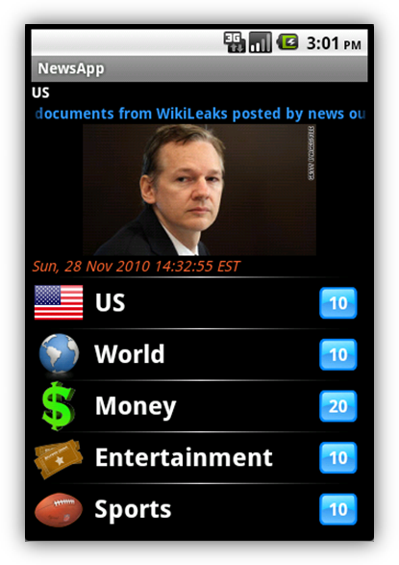 | 2. Once the application is fully loaded, the user is presented with the main screen. Here the user can select which subject of news they would like to read.
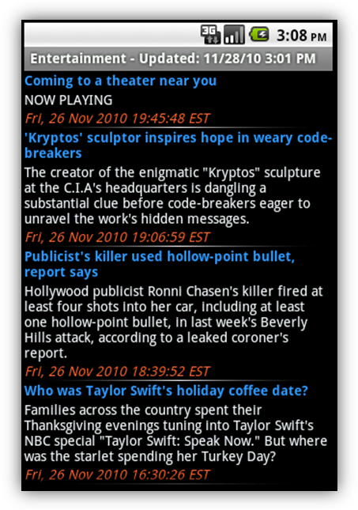 | 3a. By clicking the subject, the user is then presented with a list of articles grabbed from the CNN website.
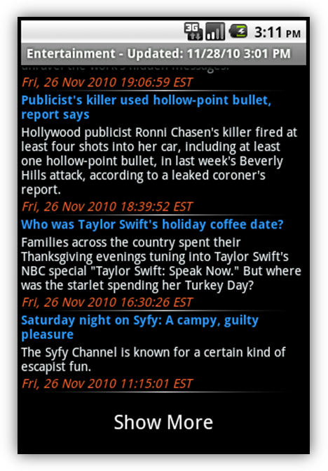 | 3b. If the user is not satisfied with the articles presented, they are able to see more articles by scrolling to the bottom of the article list and clicking “Show More”
 | 4. Once the user finds an article they are interested in, they are able to simply click the article and load it into the application.
5. The user is also presented with more options by long-clicking the article in the article list.

- Open article – Simply opens the article within the application.
- Open article in Browser – Opens the article within the Android devices built-in browser.
- Mark as Read/Unread – Marks or unmarks the article in the article list to show if the article has been read or not.

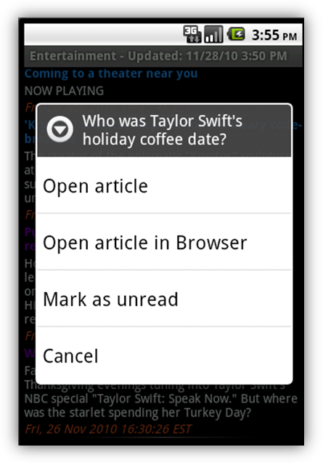 | 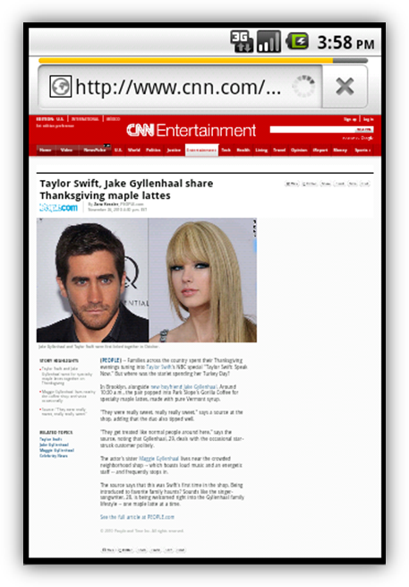
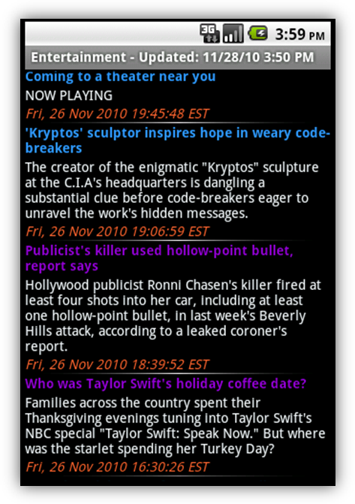 | 6. At any time, if the user wants to jump to another genre of news, they can simply click the Menu button on the Android device.
3 SOURCE CODE
Visit http://ucf.karlbanks.com/cop4331/deliverables.php to obtain the latest copy of the Source Code. The downloadable file, SourceCode.zip, contains the following:
- NewsApp.zip
- jsoup-1.3.3.jar

Note that both of these files are required to execute the News Phone Application. For more information, see the Build Instructions in Section 4 of this document.
4 BUILD INSTRUCTIONS
The following build instructions assume that the developer is using Eclipse, with ADT, and that the appropriate Android SDK (Windows, Mac, Linux) has been installed. For more help, please see the Quick Start section below.

For other IDE instructions, please visit http://developer.android.com/guide/developing/other-ide.html.
4.1 Before You Begin
NewsApp's intended target is Android 1.6. Therefore, it is REQURIED that SDK Platform Android 1.6, API 4, revision 3 be an installed package on your development computer. However, NewsApp WILL RUN with Android 1.6 or HIGHER, so your AVD may target Android 1.6 or HIGHER.
4.2 Required Libraries
The NewsApp project is dependent on the jsoup-1.3.3 or HIGHER java library. A copy can be obtained from http://ucf.karlbanks.com/cop4331/deliverables.php (in the SourceCode.zip package) or directly from http://jsoup.org/download.

Download the .jar file to the desired location on your file system. Instructions on how to reference the file will be detailed in Configuring Build Path section below.
4.3 Developing in Eclipse, with ADT
- Download the SourceCode.zip file from http://ucf.karlbanks.com/cop4331/deliverables.php.
- Extract the file contents to the desired location on your file system.
- Launch Eclipse IDE.
- Click File > Import... from the Eclipse menu bar.
- Select General > Existing Projects into Workspace
- Click on the Next > button.
- Click on the Browse... button under Select root directory.
- Navigate to the location where you saved the NewsApp project.
- Select the NewsApp folder and click the OK button
- The project should be selected in the Projects table.
- Make sure the field Copy projects into workspace is selected.
- Click on the Finish button.
- The NewsApp project should now be open in your Package Explorer.
- Please see the Configuring Build Path section below before continuing.
- If you haven't already created an AVD, see the Creating an AVD section below.
- To run NewsApp in the emulator, please see the Running on the emulator section below.
- To run NewsApp on a device, please see the Running on a device section below.
4.4 Quick Start
The steps below provide an overview of how to get started with the Android SDK. For detailed instructions, start with the Installing the SDK guide.
4.4.1 Prepare Your Development Computer
Read the System Requirements document and make sure that your development computer meets the hardware and software requirements for the Android SDK. Install any additional software needed before downloading the Android SDK. In particular, you may need to install the JDK (version 5 or 6 required) and Eclipse (version 3.4 or 3.5, needed only if you want develop using the ADT Plugin).
4.4.2 Download and Install the SDK Starter Package
Select a package and download it to your development computer. To install the SDK, simply unpack the starter package to a safe location and then add the location to your PATH.
4.4.3 Install the ADT Plugin for Eclipse
Set up a remote update site at https://dl-ssl.google.com/android/eclipse/. Install the Android Development Tools (ADT) Plugin, restart Eclipse, and set the "Android" preferences in Eclipse to point to the SDK install location. For detailed instructions, see ADT Plugin for Eclipse.
4.4.4 Add Android Platforms and Other Components to Your SDK
Use the Android SDK and AVD Manager, included in the SDK starter package, to add one or more Android platforms (for example, Android 1.6 or Android 2.2) and other components to your SDK. If you aren't sure what to add, see Which components do I need? To launch the Android SDK and AVD Manager on Windows, execute SDK Setup.exe, at the root of the SDK directory. On Mac OS X or Linux, execute the android tool in the <sdk>/tools/ folder. For detailed instructions, see Adding SDK Components.
4.5 Configuring Build Path
If installed, the proper Android library (Android 1.6) will automatically be referenced after the NewsApp project is imported into your Eclipse workspace. However, two or more error messages will prevent the application from running. The errors are due to a missing library (jsoup-1.3.3 or HIGHER). The following instructions detail how to provide a reference to the missing jsoup library:

- Right click on the NewsApp project in the Package Explorer.
- Select Build Path > Configure Build Path...
- Under the Libraries tab, select the missing jsoup-1.3.3.jar file.
- Click on the Edit... button.
- Navigate to the location where you saved the jsoup .jar file.
- Select the jsoup-1.3.3.jar or HIGHER.
- Double click or click on the OK button to select the file.
- Click on the OK button to finish referencing the jsoup library.
- The error messages should disappear and NewsApp can now be run.
4.6 Creating an AVD
An Android Virtual Device (AVD) is a device configuration for the emulator that allows you to model real world devices. In order to run an instance of the emulator, you must create an AVD.

To create an AVD from Eclipse:
- Select Window > Android SDK and AVD Manager, or click the Android SDK and AVD Manager icon in the Eclipse toolbar.
- In the Virtual Devices panel, you'll see a list of existing AVDs. Click New to create a new AVD.
- Fill in the details for the AVD.
Note: Be sure to define a target for your AVD that satisfies NewsApp's Build Target (Android 1.6 or HIGHER).
- Click Create AVD.

Your AVD is now ready and you can close the SDK and AVD Manager, create more AVDs, or launch an emulator with the AVD by selecting a device and clicking Start.

For more information about AVDs, read the Android Virtual Devices documentation.
4.7 Running on the Emulator
Before you can run NewsApp on the Android Emulator, you must create an AVD.

To run (or debug) NewsApp, select Run > Run (or Run > Debug) from the Eclipse menu bar. The ADT plugin will automatically create a default launch configuration for the NewsApp project. Eclipse will then perform the following:
- Compile the NewsApp project (if there have been changes since the last build).
- Create a default launch configuration (if one does not already exist for the project).
- Install and start NewsApp on an emulator (or device), based on the Deployment Target defined by the run configuration.

If debugging, NewsApp will start in the "Waiting For Debugger" mode. Once the debugger is attached, Eclipse will open the Debug perspective.

To set or change the launch configuration used for NewsApp, use the launch configuration manager. See Creating a Launch Configuration for information.
4.8 Running on a Device
Before you can run NewsApp on a device, you must perform some basic setup for your device:
- Declare NewsApp as debuggable in the manifest
- Enable USB Debugging on your device
- Ensure that your development computer can detect your device when connected via USB

Read Setting up a Device for Development for more information.

Once set up and your device is connected via USB, install NewsApp on the device by selecting Run > Run (or Run > Debug) from the Eclipse menu bar.

*Portions from Android's Dev Guide: http://developer.android.com/guide/developing/eclipse-adt.html

5 PROJECT LEGACY
Modification history:
Version | Date | Who | Comment
v1.0 | 10/21/10 | Jason Heintz | Initial pass through
v2.0 | 10/22/10 | Aaron Birencwaig | Worked on Analysis section
v3.0 | 10/28/10 | Jason Heintz | Worked on Roles section
v4.0 | 10/29/10 | Jason Heintz | Final compilation of document
5.1 Roles
Project Work | Team Members | % per Member
Team Webpage | Karl Banks | 100
Concept of Operations | Karl Banks | 50
Concept of Operations | Tyler Zaino | 50
Software Requirements and Specifications | Jason Heintz | 50
Software Requirements and Specifications | Aaron Birencwaig | 50
Project Management Plan | Andy Harmic | 100
Project Management Report | Andy Harmic | 50
Project Management Report | Karl Banks | 50
High-Level Design | Andy Harmic | 50
High-Level Design | Karl Banks | 50
Detailed Design | Jason Heintz | 25
Detailed Design | Tyler Zaino | 25
Detailed Design | Aaron Birencwaig | 25
Detailed Design | Stephen Rodriguez | 25
Test Plan | Stephen Rodriguez | 100
Test Results | Stephen Rodriguez | 70
Test Results | Tyler Zaino | 15
Test Results | Andy Harmic | 15
User’s Manual | Karl Banks | 50
User’s Manual | Tyler Zaino | 50
Build Instructions | Andy Harmic | 100
Project Legacy | Jason Heintz | 50
Project Legacy | Aaron Birencwaig | 50
5.2 Analysis
5.2.1 Assessment of the Quality of the Final Product
The quality of the final product is very high. The application works very well and covers all requirements and expectations, while still being user friendly. The product will work under almost any circumstances experienced by the phone except for that of catastrophic.
5.2.2 Recommended Use of the Final Product
The News Phone Application is targeted for those people that are always on the go and who still like to keep updated in what is happening in the news. The application can run on the latest Android phones and can be used at all times of the day. The only requirement needed by the application is an internet connection, which is either obtained through phone’s cellular signal or WiFi signal.

5.2.3 Known Problems
At this current date, we do not have any outstanding problems with the product. All problems that were found during development and testing were taken care of immediately. There are areas in which improvement may be desired, but there are currently no know problems with the News Phone Application.
5.2.4 Adherence to Project Plan
We have followed our project plan very closely and stayed exactly on time or ahead of schedule the entire course of the semester. Our project estimates, as far as time concerns, were all met. Since we made the estimates reasonable and realistic, we were able to adhere all deadlines. We did not have any deviations from our estimates because we took accurate guesses and with the combined efforts of the team, and we were able to complete the project and even provide over and above what was required.
5.2.5 Defect Analysis
There are no known defects in our phone application. Our application is small scale and the software development model that we used proved to be successful. We were able to create our code and test it without any errors detected in every case that we could possibly think of. Every version that we have works flawlessly to our knowledge, the only difference being the end versions are highly embellished with cosmetic and speed enhancing features.
5.2.6 Quality Assurance
We believe that the testing and quality assurance activities that we performed on the application were very adequate. We tried to test the application under any circumstance that we could foresee the end user using the application. The testing and QA was conducted in a timely manner, but the only suggestions we have for possible improvement is to have outsiders, unfamiliar with the product, test it for effectiveness.
5.2.7 Configuration Management
Our configuration management plan went very well. We specified in deliverable 1 that our plan was, “We will use Subversion to handle version and change control. Karl will be responsible for managing the version control software and repository. Every team member should make an effort to learn Subversion and the general procedures for working with a version control system. If we have difficulty using Subversion, we will resort to email to ensure that every team member has the most recent version of the project.” Our practices were quite sufficient and we were all able to access the most recent version almost always at our will. Because our Configuration Management plan worked so well, I don’t think that there is anything that I would say that we could have improved on in this area.
5.2.8 Suggestions for the Future
Our project went extremely well with very few setbacks, with this being said, there is really no need for changing the way that we approached it on projects of similar size. The suggestions for future teams would be to stay on schedule and not fall behind, make realistic expectations and utilize all of the teams members strengths, try to find a webs source for getting news updates from a news site that allows users to take its’ articles for mobile news applications, and making the code created is easy to use with other news sites in order to make the project reusable and profitable if other customers are interested in purchasing a similar product. For a project of 10 or even a 100 times this size, again all the things above would still apply, but focusing more on setting accurate time tables, understand that not everything could be predicted so allowing lapse times, and making sure everyone’s strengths are being fully utilized would be critical. In addition, more team members or a far larger time frame would be necessary for something larger as this phone application project was quite appropriate for the time allotted.

